- In a Buck-Boost converter, consider all components to be ideal. Let input voltage V_{d} be 12 ~ 48 V, output voltage V_{o} = 24 V, and f_{s} = 50 kHz, L = 50 uH. (17 points)
理想条件下，Buck-Boost变换器的输入电压V_{d}为12 ~ 48 V，输出电压V_{o}为24 V，开关频率为50 kHz，电感值为50 uH。(17分)
(1) Draw the Buck-Boost converter circuit diagram. (3 points)
画出Buck-Boost变换器的电路图。(3分)
(2) Draw the waveforms of v_{L}、i_{L}、i_{C} when the converter operating in a continuous-conduction mode. (3 points)
当变换器工作在CCM模式时，画出电感电压 、电感电流 和电容电流 的波形图。(3分)
(3) Calculate the voltage stress of switch and diode respectively. (2 points)
分别计算开关管和二极管电压应力。(2分)
(4) Calculate the minimum P_{o} that will keep the converter operating in a continuous-conduction mode for all range of V_{d}. (7 points)
试计算在全输入电压范围内能够变换器保持工作在CCM模式的最小输出功率P_{o}。(7分)
(5) What will happen if keep D =0.5 and the load R is disconnected? (2 points)
如果在负载电阻R断开时仍保持占空比D =0.5，则将会发生什么？(2分)

答：
（1）Buck-Boost 变换器电路图 (3分)：
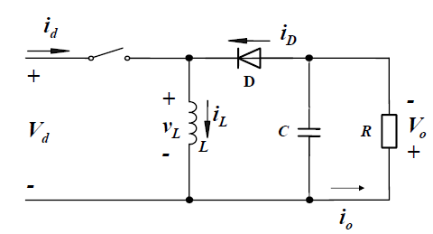
（2）、、波形 (3分)：
（3）
Switch电压应力：72 V (1分)
Diode电压应力：72 V (1分)
（4）确定占空比D范围
(1分)
(1分)
(1分)
当时，临界输出电流取最大值，得2.133 A (2分)
如果要工作于CCM模式，则，因此确保工作于CCM模式的输出功率最小值为：
51.2 W (2分)
（5）
当负载开路时，电容上的能量没有释放回路，且电感不断给电容充电，使得电容两端的电压不断抬升，最终击穿电容及其它器件。 (2分)

- A Forward converter with a demagnetizing winding (N₃=2N₁) operates in a continuous-conduction mode, V_{d}= 45~60V, V_{o}=30V, f_{s}=100kHz, P_{load} is 30W~60W. Assume all components to be ideal except the transformer magnetization inductance. Please answer the following questions: (16 points)
一个正激变换器工作在电感电流连续模式，其磁通复位绕组匝数N₃=2N₁, V_{d} = 45~60V, V_{o} =30V, f_{s} =100kHz, P_{load} 为30W~60W。除了变压器励磁电感，假设变换器中所有元器件均为理想元件。请回答以下问题。(16分)
(1) Draw the circuit diagram of this converter.
请画出正激变换器电路图。(4分)
(2) Please derive the relationship between V_{o} and V_{d}.
请推导输出电压V_{o}与输入电压V_{d}之间的关系。(3分)
(3) Calculate N₂/N₁ if this turns ratio is desired to be as small as possible.
计算N₂/N₁的最小值。(4分)
(4) With the value of N₂/N₁ from (3), calculate the minimum value of the filter inductance L.
采用(3)问中的N₂/N₁数值，计算滤波电感L的最小值。(5分)

参考答案：
(1)
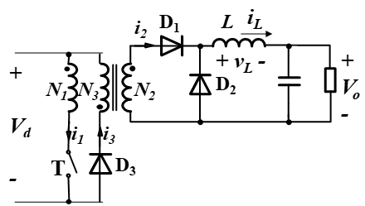（4分）
(同名端画错扣2分；二极管方向不对，扣2分；叠加扣分，两个都不对，就是0分)
(2)
（3分）

(3)
（4分）
(4) 为了保持连续，需要I_{L}≥0.5*Δi_{L}，有
（给出L表达式，给3分；计算出结果给2分）

3. (18 points) A Forward converter is to be designed with the following specifications: Input voltage range V_{d} =20V~28V, output voltage V_{o}=100V, switching frequency f_{s}=100kHz, working in CCM, N₁ is the turns of primary winding, N₂ is the turns of secondary winding, the demagnetizing winding turns N₃=2N₁. Assume all components to be ideal except the presence of transformer magnetization inductance.
(1) Please draw the circuit diagram of the Forward converter with demagnetizing winding. (3 points)
(2) Derive the maximum duty ratio D_{max}. (3 points)
(3) Calculate the minimum turns ratio N₂/N₁ of transformer. (4 points)
(4) Calculate the voltage stress of the switch? （2 points）
(5) Draw the voltage waveform across the output filter inductor v_{L} and the voltage waveform of switch v_{T} when V_{d}=20V, and mark the value. (6 points)
(1) Draw circuit (2分), Mark dotted terminals(1分)
(2)
(3分)
(3)
=3*100/20=15 (4分)
（4）
V_{T}=(1+N3/N1)*Vd=(1+2)*28=84V (2分)
(5) Waveforms： (4分)
V_{L}
0
t
200V
0
t

v_{T}
-100V
60V
20V

